|  |
| --- |
| **SOEN 6481**  **Software Systems Requirements Specification**  **Summer 2015**  Deliverable 2  Ticket Vending Machine used in Societe de Transport de Montreal  Team - D  Dharani Kumar Palani  Dhruv Ohri  Naresh Kumar  Shu Liu  Xiaodong Li  Yang Liu |



Table of Contents

**1.** **Introduction** 3

**2.** **Domain Model** 3

**2.1** **Domain Model Diagram** 3

**2.2** **Domain Model Description** 4

**2.3** **Relationships** 5

**3.** **Use Case Model** 7

**3.1** **Use case diagram of the TVM** 7

**3.2** **Recharge OPUS Card – Registered User** 8

**3.3** **Recharge OPUS Card – Non-Registered User** 9

**3.4** **Casual traveller getting pass or ticket** 11

**3.5** **Registered User reporting loss of card** 12

**3.6** **Malicious user breach TVM to obtain tickets** 13

**3.7** **Misuser uses the TVM in an inappropriate manner** 14

**3.8** **Activity diagrams** 16

**3.9** **Sequence diagrams** 19

**4.** **Team Member-Responsibility Table** 23

**5.** **Tools Used for Deliverable 2** 24

**6.** **Glossary** 24

**7.** **References** 25

# **Introduction**

Domain Model is a way to describe and model real world entities and the relationships between them which assists in solving a problem. It represents the entities or the events that are known in the business environment and creates a common vocabulary for communication among team members. It gives you a conceptual framework of the things in the problem space and helps you to focus on semantics. It takes into account, the system classes, their attributes, operations (or methods) and the relationships among them.

# **Domain Model**

# **Domain Model Diagram**

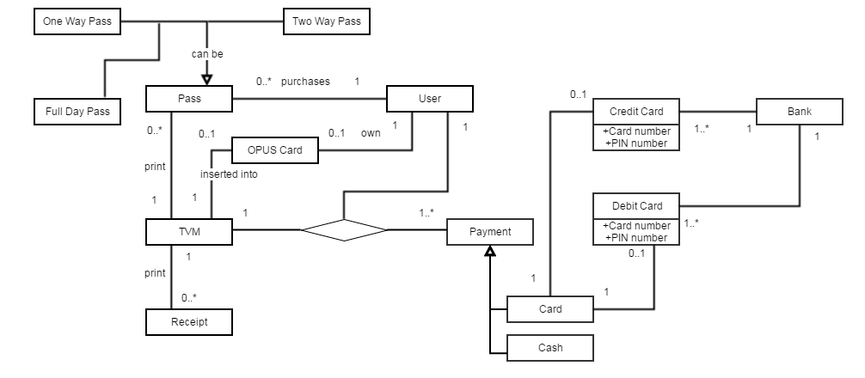Figure 1 – Domain Model of TVM

# **Domain Model Description**

**Table 1: List of all Concept Classes and their Description**

|  |  |
| --- | --- |
| **Concept**  **(Class Name)** | **Description** |
| User | Represents an entity who interacts with the TVM |
| OPUS Card | Represents an electronic card issued by to facilitate purchase of tickets and travel. |
| Pass | Represents different kinds of tickets, it can either be one way, two way or full day |
| Payment | Represents different modes of payment which can either be Cash, Debit Card or Credit Card |
| Debit | Represents an electronic card associated with a chequing or savings account of a user in bank, which is used for buying tickets or to facilitate recharging of an OPUS card. It has a valid card number and a pin number. |
| Credit | Represents an electronic card associated with a credit account of user in a bank, which is used for buying tickets or to facilitate recharging of an OPUS card. It has a valid card number and a pin number. |
| Cash | Represents use of cash as mode of payment without interacting with the bank |
| TVM | Represents interaction with User for buying a pass or user interacts to charge his/her OPUS Card and after completing the transaction prints a receipt |
| Receipt | Represents printing of receipt after the transaction is properly completed |
| Card | Represents method of payment when using Card either can be Debit Card or Credit Card |
| Bank | Represents an entity which issues a debit/credit cards to the user. During transaction EPPS interacts with the bank to get payment approval. |

# **Relationships**

The relationships between classes are need to be defined. Multiplicity describes how many instances of one class can be associated with one instance of the related class.

Some of the multiplicity symbols, we used in our DM.

1 = Exactly one;

0..1 = Zero or one;

0..*= Zero or more;

1..*= One or more;

**Table 2: List of all Concept Classes and their Relationships**

|  |  |  |  |
| --- | --- | --- | --- |
| **Source Concept** | **Target Concept** | **Relationship** | **Description** |
| User | TVM | Association | User can use TVM to buy the passes or charge his OPUS Card |
| User | Payment | Association | User makes several payment for the pass(s) or OPUS Card by Cash or Card |
| User | Pass | Association | User can buy several pass(s) to travel |
| User | OPUS Card | Association | User can own one OPUS Card or he/she does not have OPUS Card |
| TVM | Pass | Association | One TVM can print several Passes as per User desired request. It is possible that TVM does not print any Passes. |
| TVM | Payment | Association | TVM can process several payment. |
| TVM | Receipt | Association | TVM after completing the tasks of pass(s) or OPUS Card prints several receipt |
| TVM | OPUS Card | Association | Opus Card is inserted into TVM to get charged |
| Payment | Card | Inheritance | Paying by Card is one way to make payment. It can either be Credit Card or Debit Card |
| Payment | Cash | Inheritance | Payment can also be paid by Cash |
| Card | Credit Card | Association | Card can be Credit Card, which can be verified by proper Card Number and PIN Number |
| Card | Debit Card | Association | Card can be Debit Card, which can be verified by proper Card Number and PIN Number |
| Credit Card | Bank | Association | Every Credit Card belongs to one Bank so needs to verified in order to complete the transaction |
| Debit Card | Bank | Association | Every Credit Card belongs to one Bank so needs to verified in order to complete the transaction |

# **Use Case Model**

The use case model for the TVM is inspired by the stakeholder model and our analysis of possible interactions between the actors and the system.

# **Use case diagram of the TVM**



Figure 2 - Use case Model of the TVM

We have described all the use cases in the following ways

1. A set of textual descriptions in a two column table format.
2. UML Activity diagrams
3. UML Sequence diagrams.

Choice of UML activity and sequence diagrams for selective use cases has been considered after analyzing the complexity of the respective use cases.

# **Recharge OPUS Card – Registered User**

**Table 3: Recharge OPUS card by a registered user**

|  |  |
| --- | --- |
| **Use Case ID:** | UC1 |
| **Use Case Name:** | Registered user recharging opus card |
| **Priority:** | Critical |
| **Primary Actors:** | Registered User |
| **Secondary Actors:** | EPPS, IVS |
| **Description:** | A registered user wanted to recharge the OPUS card. |
| **Trigger:** | * OPUS card is fed into the TVM. * User selects language to be used (English or French). * User presents his proof of identity. * User chooses the recharge type (monthly, quarterly, custom trip passes). * User chooses the mode of payment. |
| **Pre-condition:** | * The TVM machine is active and able to process the user request. |
| **Post-conditions:** | * Upon unsuccessful validation of the OPUS card, the session will close. * Upon unsuccessful identity verification, the session will close. * If the EPPS approves, then the OPUS card will be recharged. * If the EPPS disapproves the request, then payment will be declined and the session will be closed. |
| **Normal Flow:** | 1. User inserts the OPUS card into the TVM. 2. Upon successful validation of the OPUS card, and menu for feeding the identity proof is displayed. 3. Upon successful identity verification, the user will be presented to choose the type of recharge. 4. User will then select the mode of payment. 5. In case of cash payment, the user has to deposit the required amount into the appropriate TVM slot. 6. In case of electronic mode of payment (debit or credit card) the user will be presented an option to enter the personal identification number of the respective card. 7. If the electronic payment processing system approves, then payment will be successfully processed and the OPUS card will recharged with the appropriate fare. |
| **Alternate Flow:** | 1. After successful validation of OPUS card and identity verification, the user will present the debit/credit card for electronic payment. 2. User’s information is read from the credit/debit card and PIN entry screen is displayed on the screen. 3. PIN is entered by user and submitted. 4. The PIN is then authenticated from EPPS. 5. After unsuccessful authentication, the user is asked to re-enter the pin maximum twice. User enters the correct pin in one of the tries. |
| **Exceptional Flow:** | * User enters an invalid pin while using electronic mode of payment. * User decides to quit the session * The user has to enter/re-enter the pin within a certain period of time. No response will close the session and credit/debit card will be returned to the user. * In case of cash payment, if the TVM didn’t recognize the bills or amount is incorrect, the transaction will be declined. |
| **Assumptions:** | 1. The OPUS/credit/debit card is not damaged. 2. The user carries out all the steps in a timely manner i.e. without any major lag between different interactions with the TVM machine. |

# **Recharge OPUS Card – Non-Registered User**

**Table 4: Recharge OPUS card by a non-registered user**

|  |  |
| --- | --- |
| **Use Case ID:** | UC2 |
| **Use Case Name:** | Non-Registered user recharging opus card |
| **Priority:** | Critical |
| **Primary Actors:** | Non-Registered User |
| **Secondary Actors:** | EPPS |
| **Description:** | A non-registered user wanted to recharge the OPUS card. |
| **Trigger:** | * OPUS card is fed into the TVM. * User selects language to be used (English or French). * User chooses the recharge type (monthly, quarterly, custom trip passes). * User chooses the mode of payment. |
| **Pre-condition:** | * The TVM machine is active and able to process the user request. |
| **Post-conditions:** | * Upon unsuccessful validation of the OPUS card, the session will close. * If the EPPS approves, then the OPUS card will be recharged. * If the EPPS disapproves the request, then payment will be declined and the session will be closed. |
| **Normal Flow:** | 1. User inserts the OPUS card into the TVM. 2. Upon successful validation of the OPUS card, the user will be presented with the option to choose the type of recharge. 3. After user selects the type of recharge, he will be presented with the option to choose the mode of payment. 4. In case of cash payment, the user has to deposit the required amount into the appropriate TVM slot. 5. In case of electronic mode of payment (debit or credit card) the user will be presented an option to enter the personal identification number of the respective card. 6. If the EPPS approves, then payment will be successfully processed and the OPUS card will recharged with the appropriate fare. |
| **Alternate Flow:** | 1. After successful validation of OPUS card, the user will present the debit/credit card for electronic payment. 2. User’s information is read from the credit/debit card and PIN entry screen is displayed on the screen. 3. PIN is entered by User and submitted. 4. The PIN is then authenticated from EPPS. 5. After unsuccessful authentication, the user is asked to re-enter the pin maximum twice. User enters the correct pin in one of the tries. |
| **Exceptional Flow:** | * User enters an invalid pin while using electronic mode of payment. * User decides to quit the session * The user has to enter/re-enter the pin within a certain period of time. No response will close the session and credit/debit card will be returned to the user. * In case of cash payment, if the TVM didn’t recognize the bills or amount is incorrect, the transaction will be declined. |
| **Assumptions:** | * The OPUS/credit/debit card is not damaged * The user carries out all the steps in a timely manner i.e. without any major lag between different interactions with the TVM machine. |

# **Casual traveller getting pass or ticket**

**Table 5: Casual traveller obtaining a pass or ticket from TVM**

|  |  |
| --- | --- |
| **Use Case ID:** | UC3 |
| **Use Case Name:** | Casual traveller getting a ticket |
| **Priority:** | Major |
| **Primary Actors:** | Casual traveller |
| **Secondary Actors:** | EPPS |
| **Description:** | A casual traveller getting a ticket or pass from the TVM. |
| **Trigger:** | * User selects language to be used (English or French). * User chooses the type of fare. * User chooses the mode of payment. |
| **Pre-condition:** | * The TVM machine is active and able to process the user request. |
| **Post-conditions:** | * If the EPPS approves, then the pass will be generated and issued to the user. * If the EPPS disapproves the request, then payment will be declined and the session will be closed. |
| **Normal Flow:** | 1. User selects language to be used (English or French). 2. User selects the type of fare and mode of payment. 3. In case of cash payment, the user has to deposit the required amount into the appropriate TVM slot. 4. In case of electronic mode of payment (debit or credit card) the user will be presented an option to enter the personal identification number of the respective card. 5. If the EPPS approves, then payment will be successfully processed and the appropriate fare pass/ticket would be generated and issued to the user. |
| **Alternate Flow:** | 1. User will present debit/credit card for the payment. 2. User’s information is read from the credit/debit card and PIN entry screen is displayed on the screen. 3. PIN is entered by user and submitted. 4. The PIN is then authenticated by the EPPS. 5. After unsuccessful authentication, the user is asked to re-enter the pin maximum twice. User enters the correct pin in one of the tries. |
| **Exceptional Flow:** | * User enters an invalid pin while using electronic mode of payment. * User decides to quit the session * The user has to enter/re-enter the pin within a certain period of time. No response will close the session and credit/debit card will be returned to the user. * In case of cash payment, if the TVM didn’t recognize the bills or amount is incorrect, the transaction will be declined. |
| **Assumptions:** | * The credit/debit card is not damaged * The user carries out all the steps in a timely manner i.e. without any major lag between different interactions with the TVM machine. |

# **Registered User reporting loss of card**

**Table 6: Registered user reporting loss of card**

|  |  |
| --- | --- |
| **Use Case ID:** | UC4 |
| **Use Case Name:** | A Registered User reporting loss of card. |
| **Priority:** | Critical |
| **Primary Actors:** | Registered User |
| **Secondary Actors:** | Customer Support Executive |
| **Description:** | A registered user reports the loss of card to the customer support executive so as to prevent misuse and transfer the unused balance. |
| **Trigger:** | * User calls the customer support executive. * User informs loss of card and gives the OPUS card details as well as their proof of identity. |
| **Pre-condition:** | * User calls the customer support executive during their operational hours |
| **Post-conditions:** | * Customer support executive verifies the identity and blocks the card. * Customer support executive creates a tracking request. * The IVS does not identify the user identity and hence the customer support executive closes the session. |
| **Normal Flow:** | 1. User calls the customer support executive. 2. User will be presented with an IVR (Interactive Voice Response) to choose the language of his choice. 3. User informs the customer support executive to report loss of card. 4. User will be asked to give his proof of identity. 5. Customer support executive will verify the identity of the user using IVS. 6. Upon successful verification, the customer support executive will block the card, place a request for new card and provide the user with a tracking number. |
| **Alternate Flow:** | 1. Initially the user will provide a proof of identity. 2. If the customer support executive fails to verify the proof of identity, the user will be asked to provide an alternate proof of identity. |
| **Exceptional Flow:** | * User fails to give the correct details of OPUS card; the customer support executive will close the session. * User fails to give the correct details of proof of identity; the customer support executive will close the session. * The call terminates because of technical issues. |
| **Assumptions:** | * The user is mentally stable and able to communicate either in English or French. |

# **Malicious user breach TVM to obtain tickets**

**Table 7: A Malicious user tries to breach the TVM to get tickets**

|  |  |
| --- | --- |
| **Use Case ID:** | UC5 |
| **Use Case Name:** | Malicious user tries to obtain tickets by fraudulent means. |
| **Priority:** | Critical |
| **Actor:** | Malicious user ( Hacker) |
| **Description:** | The malicious user will use fraudulent means to obtain tickets from TVM. |
| **Trigger:** | * Malicious user selects language to be used (English or French). * Malicious user chooses the type of fare. * Malicious user chooses the mode of payment. |
| **Pre-conditions:** | * The malicious user will use a fake credit/debit card. * The malicious user will use fake bills. |
| **Post-conditions:** | * Incur loss to another genuine user. * Hacker is able to obtain a valid pass of any fare. * Incur loss to the organisation managing TVM. |
| **Normal Flow:** | 1. Malicious user selects language to be used (English or French). 2. Malicious user selects the type of fare and mode of payment. 3. In case of cash payment malicious user will present fake bills in the appropriate TVM slot and on confirmation the ticket will be generated and issued to the malicious user. 4. In case of electronic mode of payment (debit or credit card) the malicious user will present fake credit/debit card and then will input personal identification number of a genuine user. 5. If the EPPS approves, then payment will be successfully processed and the appropriate fare pass/ticket would be generated and issued to the user. |
| **Alternate Flow** | * The malicious user can make use of other credit/debit cards, if the user is not able to complete the transaction with one them. |
| **Exceptional Flow:** | * Malicious user fails to succeed in his objectives due to the system being well secured. |
| **Assumptions:** | * Malicious user is able to get personal information of several genuine users to be used with multiple fake credit/debit cards. * Malicious user possess fake bills. * System is very robust and will be able to identify fake cards and bills. |

# **Misuser uses the TVM in an inappropriate manner**

**Table 8: A misuser who tries to operate the TVM inappropriately**

|  |  |
| --- | --- |
| **Use Case ID:** | UC6 |
| **Use Case Name:** | Inappropriate use of TVM by a Misuser |
| **Priority:** | Major |
| **Actor:** | Misuser |
| **Description:** | * Misuser is a legitimate user who does not have enough knowledge on how to operate the TVM. |
| **Trigger:** | * Selecting the buttons which are not assigned an action * Presenting the TVM with coins/bills which the TVM is not designed to accept and process. |
| **Pre-conditions:** | * Misuser is in a condition to operate the TVM even with inadequate knowledge of the system. |
| **Post-conditions:** | * TVM will end the session in case inappropriate options are entered. * Misuser will eventually obtain a ticket. |
| **Normal Flow:** | Misuser may end up in any one of the following:   * Misuser does not know any one of the displayed languages and end up entering inappropriate options. * Misuser inserts/swipe the card (debit/credit/OPUS) incorrectly. * Misuser enters inserts incorrect bills or inserts bills inside incorrect TVM slot. * Misuser ends up getting a ticket with incorrect fare and incorrect trip count. |
| **Alternate Flow** | * Misuser might seek help of a legitimate user or a STM stationed officer to understand how to operate the TVM correctly. |
| **Exceptional Flow:** | * The machine gets jammed because card was not inserted properly thus causing damage to the stationed TVM and no further transactions could be done. |
| **Assumptions:** | * Misuser is a legitimate user who is mentally and physically stable in order to operate the TVM. |

# **Activity diagrams**



**Figure 3 – Activity diagram of recharging OPUS card by registered and non-registered users.**

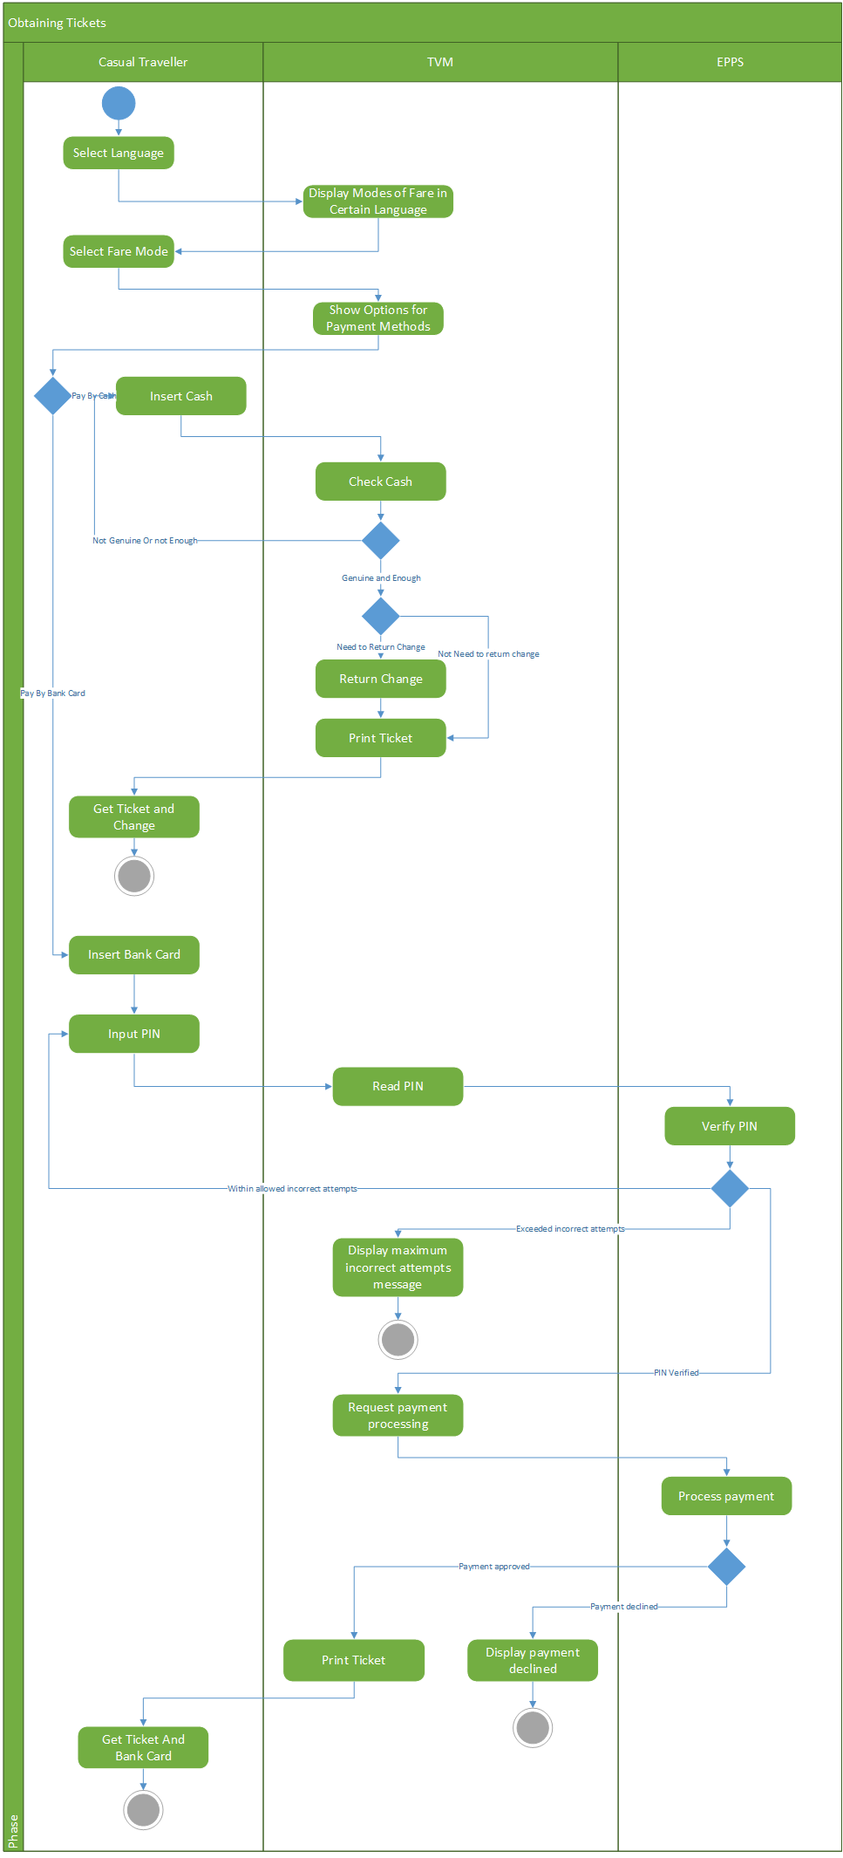

**Figure 4 – Activity diagram of a casual traveller obtaining tickets.**



**Figure 5– Activity diagram of a registered user reporting loss of card.**

# **Sequence diagrams**



**Figure 6– Sequence diagram of a registered user recharging the OPUS card.**



**Figure 7– Sequence diagram of a registered user reporting loss of card.**



**Figure 8– Sequence diagram of a Non-registered user obtaining tickets by card.**



**Figure 9– Sequence diagram of a Non-registered user obtaining tickets by cash.**



**Figure 10– Sequence diagram of a casual traveller obtaining tickets by card.**



**Figure 11– Sequence diagram of a casual traveller obtaining tickets by cash.**



**Figure 12 – Sequence diagram of a malicious user (hacker) trying to obtain tickets.**

# **Team Member-Responsibility Table**

|  |  |
| --- | --- |
| **Team Member** | **Details of Responsibilities** |
| Dharani Kumar Palani | Planning, co-ordination, management of tasks (use cases, sequence and activity diagrams), execution of P2.  Worked on the use case diagram, use case descriptions using templates, activity diagram for recharge of OPUS card by registered /non-registered users (P2). |
| Dhruv Ohri | Worked on negative use cases and use case diagram. Review of all use cases, activity and sequence diagrams and correcting them. Updating the document. (P2) |
| Naresh Kumar | Management of Team, dividing of Tasks equally among all team members. Domain Modelling, Domain Model Description and the relationships(P1) |
| Shu Liu | Domain Modelling, Domain Model Description and the relationships(P1) |
| Xiaodong Li | Worked on activity and sequence diagrams, helped in identifying use cases (P2), testing different tools |
| Yang Liu | Worked on activity and sequence diagrams, helped in identifying use cases (P2), testing different tools |

P1: Problem 1

P2: Problem 2

Link to the project wiki homepage:

[https://srs-soen-6481-d.wikispaces.com/home](https://soen6481fall14b.wikispaces.com/home)

# **Tools Used for Deliverable 2**

Following are the tools we used for your communication, creating documents, generating diagrams for different tasks:

* Wikispaces
* Whatsapp
* Yahoo Mail
* TeamViewer
* Gliffy
* Visio
* ArgoUML
* Poseidon

We have used the course materials, notes, important links presented during the lectures and the meeting minutes with Teaching Assistant to complete the required tasks for deliverable 2.

# **Glossary**

* EPPS :- Electronic Payment Processing System
* IVS :- Identity Verification System
* STM :- [Société de transport de Montréal](http://www.stm.info/en)
* TVM :- Ticket Vending Machine

# **References**

1. P. KAMTHAN, “INTRODUCTION TO DOMAIN MODELING”, SOEN 6481, Department of Computer Science and Software Engineering, Concordia University, summer, 2015.
2. P. KAMTHAN, “IMPLICATIONS OF SOFTWARE ENGINEERING PRINCIPLES FOR DOMAIN MODELING”, SOEN 6481, Department of Computer Science and Software Engineering, Concordia University, summer, 2015.
3. P. KAMTHAN, “INTRODUCTION TO USE CASE MODELING”, SOEN 6481, Department of Computer Science and Software Engineering, Concordia University, summer, 2015.